TTSK-TDZ-2C Fixed Drone Detection and Jamming Device
Technical Specifications

Table of Contents
1. Introduction 3
2. Device Overview 3
2.1 Device Name 3
2.2 Device Model 3
2.3 Device Usage 3
2.4 Device Technical Parameters 4
3. Device Features and Functions 6
4. Device Structure and Components 7
4.1 Device Four Views 8
4.2 Device List 8
5. Device Control and Interface 9
5.1 System Operation Interface 10
5.2 Device Security Protection 10
6. Device Maintenance 10

1. Introduction
With the rapid development and popularization of drone technology, drones have shown great application potential in aerial photography, agriculture, rescue, security and other fields, but at the same time they have also brought increasingly serious safety risks. Incidents such as illegal intrusions, malicious reconnaissance, and privacy violations occur frequently, posing serious threats to national security, public safety, and personal privacy. Therefore, the development of efficient and advanced drone jamming technology has become an urgent need to maintain airspace security and ensure social stability.

2. Device Overview
The fixed TTSK-TDZ-2C drone detection and jamming device consists of a drone detection system and a radio interference system, which can detect, identify, interfere with drones. It can make the drone hover, make an emergency landing or return, effectively protecting the safety of low-altitude airspace and preventing the drone from entering the defense zone. It has excellent detection and defense performance, long-distance working ability, no need for personnel on duty.

2.1 Device Name
Fixed TTSK-TDZ-2C drone detection and jamming device

2.2 Device Model
TTSK-TDZ-2C

2.3 Device Usage
Incidents such as illegal intrusions, malicious reconnaissance, and privacy violations occur frequently through drones, posing a serious threat to national security, public safety, and personal privacy. Therefore, the development of efficient and portable drone countermeasures technology has become an urgent need to maintain airspace security and ensure social stability.

2.4 Device Technical Parameters

No. | Name | Performance indicators
 | Detection frequency bands | 70MHz-6GHz full frequency band scanning, detection and display
 | Key detection frequency bands | 800MHz, 900MHz, 1.2GHz, 1.4GHz, 2.4GHz, 5.2GHz, 5.8GHz
 | FPV analog video transmission signal detection | 500MHz~6GHz scan and display
 | FPV analog video transmission signal detection distance | ≥1.5km (support viewing real-time analog video)
 | Detection distance | ≥10km (depends on working conditions)
 | Detection range | The horizontal detection angle can reach 360°  Vertical detection range: -90°～90°
 | Detection response time | The time required from when the equipment is powered on to when it discovers and reports the drone ≤ 10s
 | Direction finding accuracy | ≤±3° (RMS, Under site conditions with no obvious obstructions or obvious electromagnetic interference)
 | Detection display | Drone distance, flight altitude, speed, position (including longitude and latitude, and required to be accurate to 1 meter), drone model, drone SN code, drone take-off point, drone return point, drone real-time trajectory, etc.
 | Jamming distance | ≥3km (depends on working conditions)
 | Interference azimuth coverage | The horizontal detection angle can reach 360°
 | Jamming frequency bands | Omnidirectional jamming frequency bands:  420MHz-480MHz 50W  650MHz-730MHz 50W  740MHz-840MHz 50W  860MHz-930MHz 50W  1080MHz-1200MHz 50W  1200MHz-1340MHz 50W  1340MHz-1500MHz 50W  1560MHz-1620MHz 50W  4880MHz-5080MHz 50W  5100MHz-5300MHz 50W  5870MHz-6060MHz 50W  5720MHz-5860MHz 100W  2385MHz-2490MHz 100W
 | Jamming frequency bands | Directional jamming frequency bands:  850MHz-950MHz 50W  2385MHz-2490MHz 50W  5720MHz -5860MHz 50W  5100MHz-5300MHz 30W
 | Jamming response time | ≤7s
 | Cloud platform | - Unattended and manual control functions: The system can automatically complete drone detection, identification, alerting, localization, and mitigation. The software automatically activates jamming devices, and based on the drone's location information from monitoring devices, it provides fully automated tracking interference.  - Blacklist and whitelist functions  (3) High-definition GIS system: It presents surrounding environment information, device deployment points, and other relevant details.  (4) Equipped with log playback and statistical records: drone intrusion log, the log displays angle, alarm time, frequency information, drone intrusion records can be played back, and drone intrusion statistical reports can be provided;  (5) Positioning and automatic north calibration: The system features GPS positioning, allowing the location to be marked on a map, and it is capable of automatic north calibration.  (6) It has drone signal extraction and addition functions: it can automatically collect unknown drone signals, automatically extract parameters, and add them to the drone feature library through manual confirmation;  (7) It has the ability to display device offline, standby, power-off, and abnormal status.
 | Jamming device (omnidirectional)*2 | Weight: single device≤31kg
 | Jamming device (omnidirectional)*2 | Size: Length 520mm*width 465mm*height 275mm
 | Jamming device (omnidirectional)*2 | Description:  Main device and secondary device (see the logo) to achieve omnidirectional jamming
 | Jamming device (directional)*4 | Weight: single device≤5kg
 | Jamming device (directional)*4 | Size: Length320mm*width 320mm*height 110mm
 | Jamming device (directional)*4 | Description:  Divided into four sides, four host devices in total (see the logo), to realize directional jamming in key frequency bands
 | Detection device weight | ≤15kg
 | Detection device size | Diameter 400mm*height 370mm
 | Device total weight | ≤150kg
 | Device total size | Diameter 1000mm*height 2400mm
 | Working temperature | -40℃~60℃

3. Device Features and Functions
The fixed TTSK-TDZ-2C drone detection and jamming device consists of a drone detection system and a radio interference system, which can detect, identify, interfere with drones. It can make the drone hover, make an emergency landing or return, effectively protecting the safety of low-altitude airspace and preventing the drone from entering the defense zone. It has excellent detection and defense performance, long-distance working ability, no need for personnel on duty.

Full frequency band detection: 70MHz-6GHz full frequency band detection, covering all drone models.
Super interference with FPV drones: Effective defense against radio frequency flight control and FPV drones, with outstanding interference effect.
Simulated image transmission interference capability: Effectively prevents the intrusion of drones using simulated image transmission
Multiple interference modes: Directional interference in key frequency bands and omnidirectional interference covering all frequency bands, effectively preventing the intrusion of high-power drones and non-standard frequency band drones.
Strong scalability: Expand and integrate radar, optoelectronics, navigation and deception and other equipment, support work by one equipment and by multiple equipment network .
Unattended: Realize all-weather automatic and intelligent execution of preset plans. When a drone is detected, it can quickly coordinate strikes outside the defense zone.
Military quality: Covered by aviation aluminum fuselage, no fear of high and low temperatures, strong environmental adaptability.
Signal collection: Built-in drone signal collection function, which can collect and learn unknown signals.
Customized services: Customized intelligent solutions according to needs to provide customers with better defense effects.

4. Device Structure and Components
The fixed TTSK-TDZ-2C drone detection and jamming equipment consists of a drone detection system, a radio interference system, a control motherboard, a support rod assembly, main body shell, and power supply assembly, etc.

4.1 Device Four Views
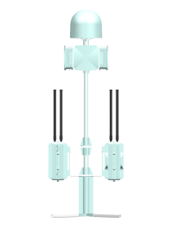 | 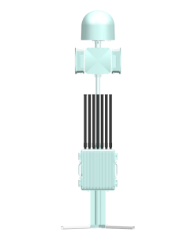
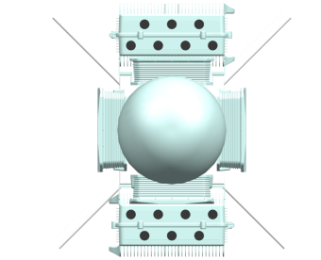 | 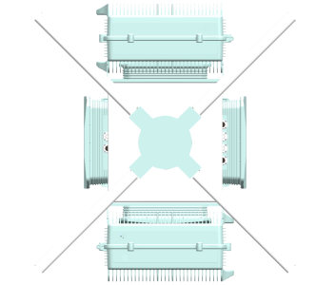

4.2 Device List
No. | Name | Picture | Number | Size (mm) | Weight (kg)
1 | Detection host | 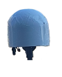 | 1 | Diameter 400*height 370 | 13.5
2 | Jamming host | 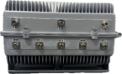 | 2 | Length 520*width 465*height 275 | 30.25
3 | Directional jamming host | 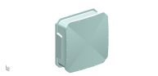 | 4 | 320mm*320mm*110mm | 4.85
4 | Jamming antenna | 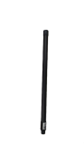 | 13 | Diameter 32*height 600 | 0.2
5 | Support rod assembly | 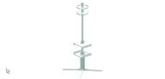 | 1 | Diameter 50*height 500 | 46
6 | Cable | 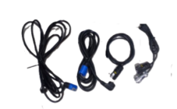 | 12 | / | 0.15
7 | Detection host aviation case | 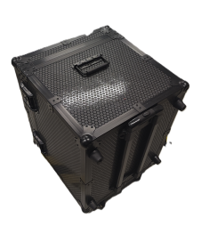 | 1 | 680mm*600mm*480mm | 15.05
8 | Omnidirectional jamming host aviation case | 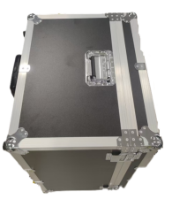 | 2 | 470mm*570mm*710mm | 27.5
9 | Support rod assembly aviation case |  | 1 | 1700mm*440mm*350mm | 12.5
10 | Directional jamming host aviation case |  | 1 | 620mm*430mm*430mm | 7.9
- Device Control and Interface
Product interface definition:
Detection device power supply interface: 3-core power cord (AC220V 50Hz)
Detection device data interface: LAN (RJ45), WAN (RJ45), DATA (9-core)
Directional jamming device power supply interface: 3-core power cord (DC28V 50Hz)
Directional jamming device data interface: DATA (9-core)
Omnidirectional jamming device power supply interface: 3-core power cord (AC220V 50Hz)
Omnidirectional jamming device data interface: DATA (9-core)

5.1 System Operation Interface
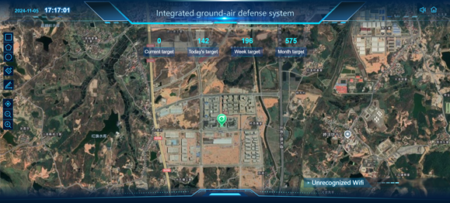

5.2 Device Security Protection
Aviation Case：
Omnidirectional host packaging size: 470mm*570mm*710mm
Directional host packaging size: 620mm*430mm*430mm
Detection packaging size: 680mm*600mm*480mm
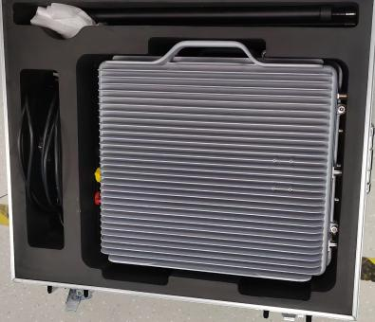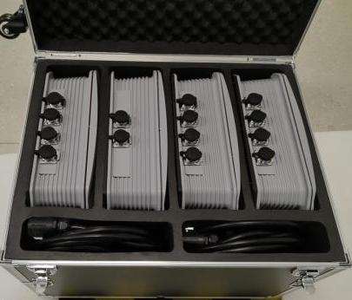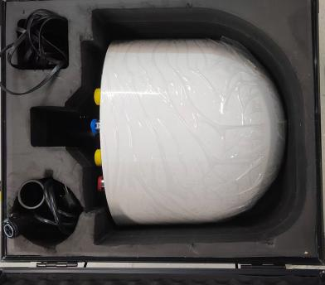

Device Maintenance
Power on the device regularly to check its status.

